Traffic Light Control using Deep Reinforcement Learning
Divya Boya^{1, a)}, Sravya Boya^{1, b)}, Ayush Singh^{1, c)}, Varun Anshul Govindu^{1, d)}, Baddaram Surya Teja^{1, e)}, Tata Dhakshith^{1, f)}
¹Department of Computer Science and Engineering, GRIET, Hyderabad, Telangana, India.

Corresponding Author:
- divyaboya1291@gmail.com
- sravyaboya1214@gmail.com
- ayushsinghp12@gmail.com
- govindhuvarunanshul@gmail.com
- ridiculousrobin723@gmail.com
- tatadhakshit@gmail.com

Abstract. The offered system is founded on the reinforcement learning scheme where the traffic intersection is posed as a learning agent. And such agents are trained with the help of the stable policy optimization strategies along with the deep neural network structures. The state representation uses the simulated traffic data, the choice of the action uses the learned policies and the continuous improvement uses the feedback loops on the rewards. Therefore, the reinforcement system can learn and adjust to the various conditions and as a result, its functioning can vary throughout the training process and the more complicated traffic situations can be seen by this system. Thus, it is envisioned to develop a definition of the traffic optimization, which would be multi - objective learning based on which the best solution would have been found based on the criterion developed and which would enable to manage traffic more efficiently through simplification of the decisions made based on intelligent algorithms within the frames of transport management technologies. Keywords- Reinforcement Learning, Traffic Signal Control, Multi-agent Systems.

INTRODUCTION
One of the significant issues in the modern world is overcrowding of vehicles. In addition, the old traffic management systems cannot match the booming traffic and the population in the cities. The rule-based or fixed-time traffic lights which had been used in the earlier decades, are showing to be inadequate in the modern day complex, dynamic traffic flow in cities. This has compelled the researchers to explore the intelligent control system that can ensure that it adapts itself in real time to achieve the traffic flow optimization in a more efficient way. Reinforcement learning (RL) is one of the innovations in the field of smart problem-solving and AI implementation. It allows an agent to find the best possible strategies through the exploration of various alternatives and provides an evaluation at this particular step. In this project, we would like to investigate the novelty curious deep reinforcement learning model (PPO) to the traffic lights control system with the SUMO simulator. The use of RL to control traffic lights would make it possible to introduce the practice of dynamically changing control policies based on a current load. This is with the aim of creating a system that can sufficiently take care of itself and be able to respond to the new emerging environment as well as enhance the general traffic flow.

LITERATURE SURVEY
The use of Deep Reinforcement Learning (DRL) in controlling the traffic lights has moved and changed at an accelerated rate within the last few years and has generated a vast amount of literature. The section is a part of the literature review where the literature is divided into four thematic groups, namely large-scale multi-agent and graph-based coordination, sophisticated policy optimization and hybrid learning structures, expert data fusion and communication megabanding, and synthesized literature that reveals the challenges faced in the field.

2.1 Large-Scale Multi-Agent and Graph-Based Coordination

The inherent problem of scaling the DRL-based traffic signal control to large, connected urban networks is a key challenge and a number of recent papers have handled it in terms of multi-agent and graph-based structure. Jia and Ji (2025) suggested that incorporating Multi- Agent Deep Reinforcement Learning (MADRL) with a Spatio-Temporal Attention Mechanism is useful to address poly-NP complexity of coordinating signals in large road systems. Their system was tested on a 4x4 grid in the environment of the simulation of SUMO, which has proven to be better coordinated at scale. Likewise, Wang et al. (2024) proposed a hybrid evolutionary algorithm named AHMOA, which combines Genetic Algorithms (GA), Differential Evolution (DE), and Particle Swarm Optimization (PSO) to solve the problem of latency as well as maximizing the throughput at the same time. Being applied on real-life data of Manhattan city and Paris, AHMOA is nonetheless a significant advance toward practical applicability, although its use of simulation to label it still stands out as a limitation. The article of Wang, Han et al. (2023) tries to solve the same issue in terms of Graph Neural Networks (GNNs) and introduces a G-DESAC model, which consists of a GNN-based state representation, and a Dynamic Entropy-Constrained Soft Actor-Critic (DESAC) algorithm. Their method based on the representation of real traffic data of Jinan provides a principled model of the complex connectivity of urban signal networks by capturing a set of spatial relationships among intersections.

2.2 Advanced Policy Optimization and Hybrid Learning Frameworks

It is the other sphere, that one can call the improvement sphere, that tries to create new techniques and tools that will allow the DRL learning to be more stable and quicker and efficient. According to Li, Huang and Liu (2025), EGLight uses a trial-and-error training of DRL, which is backed by a policy level of imitation of an already specified expert model. Even without an expert recommending it, EGLight help allows the convergence to proceed faster, and the quality of control to be better, especially during the first phases of training. Similar studies were done by Bokade, Jin, and Du in 2025 on a G-DESAC structure which handles the GNN based state representations which is placed within an entropy constrained Soft Actor-Critic model which evolves over run time - the researchers mention that deploying the model in real time would require large computational resources which is one of the main limitations to a realistic application. This method was used in Chen and Tang (2019) on a case-by-case intersection level, with Chen and Tang (2023) being able to convince me of Proximal Policy Optimization (PPO) in both its DRL form and as an actor-critic method. In this way, it is possible to decrease numerous uncertainties and improve time signal optimization functioning of the road traffic control, as any single unmeshed intersection of a complex Markov Decision Process (MDP) model.

2.3 Specialized Data Fusion and Communication Integration

In addition to enhancement of algorithms, scientists have been exposed to introduction of new sensing and communication modalities to enhance inputs the DRL controllers receive. UCB-MRL-CSFL is a framework suggested by Belguith and Fakhfakh (2025), which carries out a real-time multi-object analysis of video feeds alongside estimating traffic intensity to maximize signal timings. This methodology shifts the constant loop detector data to richer visual perception, but is restricted at the moment to single intersection on-demand situations. An even less traditional combination was sought by Vieira and Galvao (2025), who connected Visible Light Communication (VLC) technology with signal control with DRL, simulated in a compound environment based on SUMO and OMNeT++. Although the idea is a novel one, the lack of real-world VLC infrastructure is one of the largest hurdles of the validation that hinders the practical applicability of the approach itself at the moment.

2.4 Surveys on Field Gaps and Real-World Challenges

To supplement the main study, current survey studies have scanned the advancement of the field and found out some systemic gaps that endure. According to Saadi, Abghour, et al. (2023), a comprehensive review of methods of reinforcement and deep reinforcement learning addressing the coordination of an intelligent traffic light revealed a critical and pervasive gap: on the one hand, the presence of capable simulation tools, including SUMO and CityFlow, allows addressing the problem of managing an intelligent traffic light; on the other hand, on most studies, the analysis is limited to artificial settings at the expense of a large volume of real-world traffic data at actual locations of traffic light deployment. A similar survey of machine learning and deep learning in traffic management was conducted by Almukhalfi, Noor, and Noor (2024), who suggested the creation of standard benchmark datasets to allow a comparatively fair and universal evaluation of a DRL model between the models of various three-dimensional city layouts. Collectively, these surveys highlight two broad-based issues that drive on-going research the simulation-to-reality gap and the absence of shared evaluation methods.

To conclude, although the literature shows significant advances in the field of DRL-driven traffic signal control, including the use of single-intersection PPO agents, as well as large-scale multi-agent GNN architectures, a number of critical issues in the domain remain, including scalability, real-world validation, computational capabilities, and standard evaluation. The paper at hand is going to fill in one or more of these gaps, based on the backgrounds set by the reviewed studies.

RESEARCH GAPS

The use of blockchain technology in pharmaceutical supply chain management has been identified as a promising area of research for enhancing drug traceability and combating counterfeit drugs [3]. This technology is known for its transparency, security, and immutability properties, making it an ideal choice for managing pharmaceutical data. Although tremendous progress has been made in this area, there are still some research gaps that need to be filled. It is possible to enhance the scalability and efficiency of blockchain-based drug traceability systems, and future research should aim at designing efficient consensus algorithms and optimized smart contracts that can process a large number of transactions with low latency and cost [5][12]. It is also important to design user-friendly interfaces and mobile applications that enable manufacturers, distributors, pharmacies, and consumers to conveniently interact with blockchain systems and check the authenticity of drugs using QR codes.

Moreover, there is a requirement to enhance the integration of blockchain systems with other technologies such as IoT sensors, cloud storage, and existing pharmaceutical databases to ensure proper real-time monitoring and synchronization of data [6][10]. Future research should aim to design flexible and adaptable blockchain models that can handle varying pharmaceutical supply chain models and regulations. Moreover, it is required to mitigate security and privacy issues by incorporating robust encryption, secure authentication processes, and protection against smart contract attacks and unauthorized access [11]. Moreover, it is required to ensure the reliability, stability, and long-term functionality of blockchain-based systems such as MediChain, and future research should aim to enhance the robustness of such systems against failures. By addressing the above research gaps, it will be possible to develop secure, scalable, and efficient blockchain-based pharmaceutical supply chain systems that can improve transparency, facilitate drug tracing, and prevent counterfeit drugs.
.

METHODOLOGY
3.1 Overview

In this section, the suggested concept of adaptive traffic signal control through Deep Reinforcement Learning (DRL) is outlined. The system aims to reduce the amount of traffic congestion on the road by switching the time of the signals at the real-life intersection dynamically to optimize the signal phases on the basis of SUMO (Simulation of Urban MObility) environment. The agent uses the Proximal Policy Optimization (PPO) algorithm that is enhanced with the use of curiosity-based exploration to learn strong generalizable control policies in the context of the simulated traffic environment during the continuous interaction.

3.2 Limitations of Existing Approaches

Although previous research in the field of the DRL-based traffic signal control has shown that the positive outcomes can be achieved, a number of severe gaps that should be addressed remain. Actuated and fixed-time controllers do not adjust to real-time fluctuation in traffic demand especially during peak hours or incidental congestions. Numerous DRL methods use hand-engineered and fixed reward functions, which are unlikely to be generalizable to different traffic conditions and again would result in converging the agent to local sub-optimal strategies. Moreover, non-adaptive e-greedy or entropy-based exploration algorithms are generally inadequate in traffic models having a sparse reward structure, where the agent can explore previously explored state space without sufficiently exploring potentially rewarding yet rarely visited cases. Most models have challenges in dealing with emergency vehicle preemption, which is another practical limitation. Lastly, most of the current frameworks measure performance over synthetic grid networks as opposed to the real road topology, which restricts applicability to the real world.

3.3 Proposed Contributions and Advantages

The above limitations have been addressed by adopting the target design decisions in the proposed system. The first thing to note is that the composite rewarding functional is created, which imposes penalties on the length of the queue and the wasted waiting time and rewards throughput and the successful travel time, wherein emergency vehicle bylaws are clearly defined. This is a multi-objective formulation which entails a pressure on the agent to maximize conflicting traffic statistics simultaneously. Second, curiosity-driven exploration is introduced, and it is encapsulated in a CuriosityEnvWrapper which is the integration of learned StatePredictor network with a NoveltyTracker. StatePredictor is an example of predictors that compute the error of a prediction on unseen states and the NoveltyTracker is an example of predictors that rewards visit counts, a combination of an intrinsic reward signal and rewards the agent to explore many different traffic conditions than would be rewarded by the extrinsic reward signal alone. Third, to alleviate premature convergence and increase the capacity of the learned policy to resist signal variations in the real-life, a DynamicNoiseWrapper is applied to introduce approximately exponentially increasing Gaussian noise to the actions in the training process. Fourth, it implements adaptive learning rate decay that is executed with the help of a custom callback and allows training to stabilize later in stages when the conservative policy updates are necessary. The final step is to apply the framework to a real open street map based road network with SUMO and TraCI, so that the analysis is done using realistic intersection geometry and traffic.

3.4 Proposed System Architecture

The general architecture is depicted in Fig. 1. This system can be described as a closed-loop DRL training paradigm which consists of four closely interacting modules: the Traffic Simulation Module, the State and Reward Processing Module, the DRL Controller Module and the Adaptive Signal Execution Module. The agent is then in a continual interaction with the simulation, and changing its policy based on the PPO training loop to optimize the delay and maximize throughput.

3.5 System Modules

3.5.1 Traffic Simulation Module

The simulator is the Traffic Simulation Module where the agent of reinforcement learning functions. It is simulated with SUMO with the support of the realistic road network based on OpenStreetMap and connected via the TraCI interface. Each step of the simulation process is simulated by the module generating real-time observations in terms of the number of vehicles in a queue, the number of vehicles per lane, the waiting times in each lane, average velocity of the vehicles on the roadway, and the present position of the traffic signal. A traffic density scaling factor is uniformly sampled from [1.0, 2.0] and this is used to initialize the simulation at the beginning of each episode, which brings in stochastic variations in traffic load per training episode. Once every episode has a maximum lane capacity of 70 vehicles and a maximum of 1,000 simulation steps.
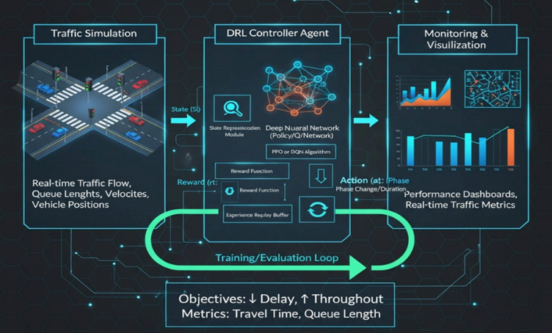

FIGURE 1. Proposed DRL-based Traffic Signal Control Architecture

3.5.2 State and Reward Processing Module

This is an element that translates raw simulation input into structured inputs to the DRL agent and finds the scalar reward signal used to optimize the policy. The state vector is an 8-dimensional normalized array of four quantities of traffic queue length, waiting time, throughput, travel time all normalized with running min-max bounds, and conveniently represented by a phase array of dimension (num phases +1) = 4 which represents the active signal phase. Box([0,1] 8) is referred to as the formal observation space.
The reward functionality is as follows:

$r = -0.2 · q̂ - 0.2 · ŵ + 0.3 · p̂ - 0.1 · t̂ + r_emg$ (1)

in which q̂, ŵ, p̂ and t̂ are the normalized queue length, waiting time, throughput and travel time respectively, and r_ emg is a new emergency vehicle reward calculated by using an exponential decay process: r_emg = Σ base_reward × decay_rate^i in which the base_reward = 1.0 and decay_rate = 0.9 represent newly detected emergency vehicles in the current step. Such a formulation encourages normal traffic efficiency, as well as, safe clearance of emergency vehicles.

3.5.3 DRL Controller Module

The primary decision-making system of the system is DRA Controller Module. It is implemented by the Proximal Policy Optimization (PPO) algorithm with an MLP (Multi-Layer Perceptrone) policy and was trained with the Stable-Baselines3 library in a CUDA-enabled graphics card. This action space is a continuous box of (-1, 1) -3 and it is a normalization of the change of each of the three phases of a signal in terms of duration. The PPO model is learned with a learning rate of 3x10-4, g = 0.99, clips 0.3, entropy coefficient = 0.03, nsteps = 4096 and nepochs = 10 and gradient clipping of a maximum norm of 0.5. A reflection LearningRateDecayCallback applies exponential learning rate decay (decayrate = 0.95) to the learning rate every 1,000 steps of training to promote the later training phases to converge steadily. A total of 40,000 timesteps are used in the model that are assessed after 4,000 timesteps. To make the exploration further than traditional entropy regularization, CuriosityEnvWrapper incorporates the controller. This wrapper is founded on two smaller components, the StatePredictor which is a two-layer neural network (Linear(statedim + actiondim - 128) - ReLU - Linear(128 - statedim)) trained online to predict the next state, given current state-action pair; and the NoveltyTracker which keeps track of visit counts of the key state space using discrete keys and provides a bonus of 1 /[?]n(s) which counts the number of times state s has been visited. A combination of intrinsic reward program has been adopted whereby the intrinsic reward of prediction error and novelty bonus is 5-fold to the extrinsic reward respectively to provide a high incentive to exploration instead of destabilizing the major learning goal.

Moreover, a DynamicNoiseWrapper is used to add a zero-mean Gaussian noise with linearly increasing standard deviation (σ_t = min(σ_max, σ_0 + growth_rate × t)) to all actions during training, where σ_0 = 0.10, σ_max = 0.5, and growth_rate = 0.0001. This fosters expansion of exploration of the action space in the long run.

3.5.4 Adaptive Signal Execution Module

The Adaptive Signal Execution Module transforms the continuous action response of the DRL controller to actual traffic signal orders that are represented in the SUMO simulation through TraCI. The raw action array a [?] [minimumduration, maximumduration] = [10, 60] seconds linearly rescaled to durationi = 10 + ((a i + 1)/2) x 50. Action smoothing is realized by adding time-varying Gaussian noise (s = 0.1 + 0.0001 x step) prior to executing and recent history is stored in a sliding window stack of length 5 to allow temporal consistency.

Each signal phase is given a phase of green of a certain duration (through traci.trafficlight.setPhase and traci.trafficlight.setPhaseDuration) which is then followed by a required yellow phase of 7 seconds before the next phase is triggered. Emergency vehicle preemption is different: once any controlled lane notices a vehicle type of the type of the emergency, the module allows the corresponding phase the maximum possible amount of green time (60 seconds), performs the yellow transition and skips the PPO-based phase scheduling until the emergency has been cleared. This ensures a safe and legally appropriate conduct of matters of critical nature.

3.6 Training Procedure
The training process takes a conventional episodic DRL loop. Each episode begins with the reset of the SUMO environment with a randomly sampled scaling factor of the traffic and the agent is initialized by asking the simulation to provide present indications of the traffic. In every step, PPO policy picks a continuous action, smoothes, scales, and implements them on the simulation through the Adaptive Signal Execution Module. Simulation is then furthered by 5 steps (stepup = 5) in each decision-cycle, and the following state and reward then calculated. Experience is accumulated into the rollout buffer of PPO and made to update policy at each nsteps = 4096 timestep. An EvalCallback tracks the performance after each 4,000 steps and packs the best model check-point into disk. The whole training process takes 40,000 steps with acceleration through CUDA.

IMPLEMENTATIONS
4.1 Development Environment and Hardware

The Python was used to implement the system and was trained on a machine with an NVIDIA CUDA-capable GPU, to speed up the PPO training loop. The simulation backend was executable locally, and the SUMO process was connected to the TraCI socket interface by means of subprocess calls. TensorBoard was also employed during training to record and track all the indicators in real time.

4.2 Traffic Simulation Environment — SUMO

Simulation of Urban Mobility (SUMO) is a portable microscopic traffic simulation package in opensource that is capable of scaling to large road networks. The only simulation backend utilized in this work is SUMO version 1.x that offers a real-world to train and test the agent of the DRL. The road network was obtained in direct importation of OpenStreetMap (OSM) with the netconvert tool of the SUMO delivering a real-life intersection network with the correct lane geometries, the turn restrictions and signal phases. Vehicle paths were created by SUMO, randomTrips utility and scaled at runtime with the --scale flag to add some stochastic variation to density in individual episodes in traffic.

The communication between the Python-based RL agent and the SUMO process was bi- directional with step-by-step communication using the Traffic Control Interface (TraCI) API. At every decision point, TraCI was called to retrieve per-lane statistics such as a queue length (traci.lane.getLastStepHalmingNumber) and cumulative waiting time (traci.lane.getWaitingTime), vehicle throughput, average travel time and the current signal phase. Also used with TraCI was the issuance of control commands by calling traci.trafficlight.setPhase and traci.trafficlight.setPhaseDuration. The program was assumed to have 70 vehicles as the maximum capacity of the lanes, the yellow phase was set to 7 seconds, and the green phase was set to the range [10, 60] seconds.

4.3 Reinforcement Learning Framework — Stable-Baselines3

The Proximal Policy Optimization (PPO) algorithm was trained with the Stable-Baselines3 (SB3) library (version [?] 1.6), which is a stable and tested group of RL algorithm implementations that are based on PyTorch. SB3 offers unified interfaces to interact with the environment (through the Gymnasium API), policy networks, rollout buffers, training callbacks, and is much faster to develop. The policy architecture was the MlpPolicy, and it comprised of entirely connected neural networks in the actor and critic heads. Environment was surrounded by Monitor class of SB3, which was passing episode rewards and lengths, and verified by checkenv before training.

4.4 Algorithm — Proximal Policy Optimization (PPO)

PPO is an on-policy actor-critic algorithm that constrains the magnitude of policy updates using a clipped surrogate objective, preventing destructively large gradient steps. The clipped objective is defined as:
L_CLIP(θ) = E[min(r_t(θ) Â_t, clip(r_t(θ), 1−ε, 1+ε) Â_t)]

where r_t(θ) = π_θ(a_t|s_t) / π_θ_old(a_t|s_t) is the probability ratio between the new and old policy, Â_t is the generalized advantage estimate, and ε = 0.3 is the clip range used in this work. The full training objective also includes a value function loss coefficient and an entropy bonus (ent_coef = 0.03) to encourage exploration. The hyperparameters used are summarized in Table 1.

TABLE 1. PPO Hyperparameter Configuration

Hyperparameter | Value
Algorithm | PPO (MlpPolicy)
Learning Rate | 3 × 10⁻⁴ (with decay)
Discount Factor (γ) | 0.99
Clip Range (ε) | 0.3
Entropy Coefficient | 0.03
n_steps | 4096
n_epochs | 10
Max Gradient Norm | 0.5
Total Timesteps | 40,000
Evaluation Frequency | Every 4,000 steps

4.5 Curiosity-Driven Exploration

Two more elements were adopted to address the exploration drawbacks of traditional PPO within the sparse-reward traffic settings. StatePredictor This is a PyTorch (Linear to ReLU to Linear) two-layered feedforward neural network that is trained to predict the successive state of the environment, given the state-action example of the present state. Its prediction error is a marker of novelty of states. The NoveltyTracker uses a dictionary of count of state visits discretized, and a bonus of 1/[?]n(s) on a state visit, with decreasing reward on repeated visitations. The two are added into an intrinsic reward in the CuriosityEnvWrapper, and injected on top of the scaled extrinsic reward (scaled by 5x) each time a step takes place in the environment

4.6 Key Libraries and Tools

TABLE 2. Libraries and Tools Used

Library/ Tool | Purpose
SUMO | Traffic microscopic simulation environment
TraCI (Python) | SUMO real-time control & data extraction API
Stable-Baselines3 | PPO algorithm implementation
PyTorch | StatePredictor neural network & GPU training
Gymnasium | RL environment interface standard
NumPy | Numerical state processing & normalization
TensorBoard | Training metric logging and visualization
Pandas / Matplotlib | Post-training result analysis and plotting

RESULTS AND DISCUSSIONS
5.1 Rollout Performance — Episode Reward and Length

This section gives the training and evaluation outcomes of proposed PPO based DRL traffic signal control system. All the measurements were recorded by TensorBoard during 40,000 training timesteps (Run: PPO 70 6 total training time: =3.4 hours). These findings are presented in four subsections, including rollout performance, the consistency of training, policy learning dynamics and level 4 traffic results.

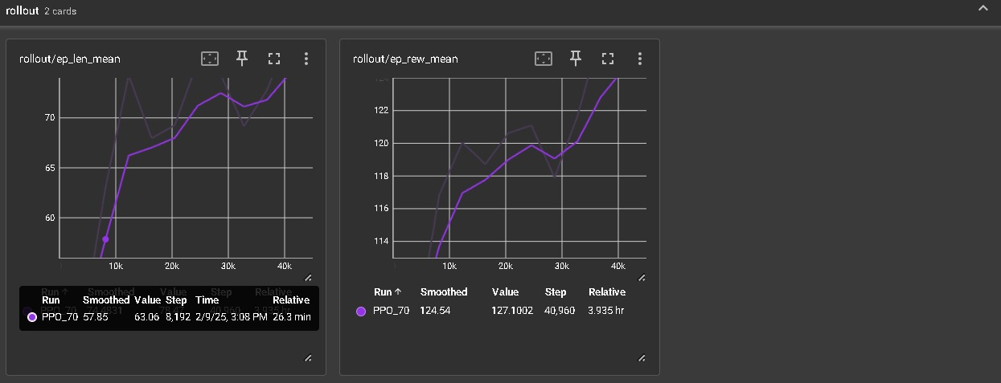
FIGURE 2. Rollout metrics — mean episode length (left) and mean episode reward (right) over 40,000 training steps

Fig. 2 shows the rollout statistics that were taken during training. The reward (rollout/eprewmean) of the mean episode demonstrates a steady positive growth during training with an initial approximate of 114, which is then gradually increased to reach a final smooth value of 124.54 in the 40,960 th step. This smooth progression proves the fact that the agent is learning to produce better quality signal control policies as time goes by. The average episode length (rollout/eplenmean) also rises to an average of 60 to an estimated balance of 63.06 (step 8,192), and then rises to about 73 towards the end of training. The rising episode length also shows that the agent is maintaining longer and more complex traffic situations without initiating an early termination which is a measure of greater strength in managing the different traffic situations.

5.2 Evaluation Performance — Mean Reward and Episode Length

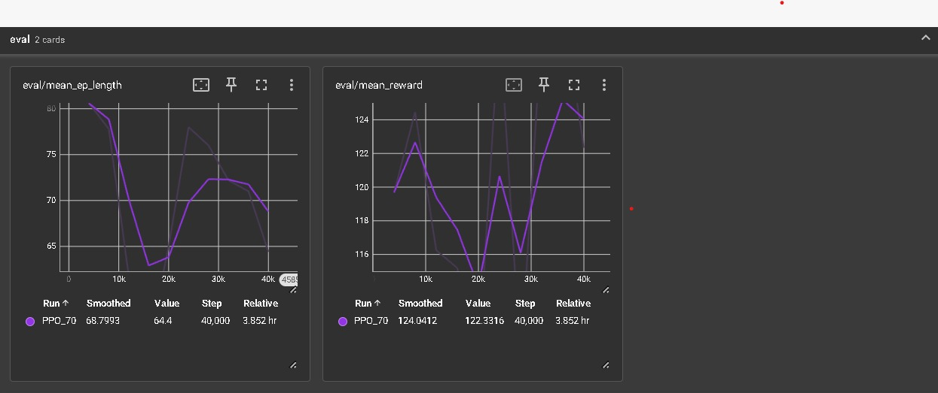
Figure 3. Evaluation metrics — mean episode length (left) and mean reward (right) across evaluation checkpoints

Fig. 3 presents evaluation metrics that were gathered by the EvalCallback in 4,000 time intervals. The eval/meanreward curve shows an upward trend in general, with the smoothed value nearing 124.04 at the last checkpoint (step 40,000), which is virtually identical to the rollout reward, and shows that the agent generalizes over the distribution that it was trained on. Although there is an oscillation in the evaluation reward especially a dip in the range of steps between 20k and 30k. The policy converts and attains its optimum values during the last training phase. This unstable temporary fit can be seen as a result of the policy reorganizing its learned behaviour in response to the decays of the learning rate and the recalls of the exploration landscape by the curiosity signal. The eval/meaneplength indicates the same pattern of recovery, as it is stabilised around 70-72 steps during the last evaluation rounds and this implies a consistent completion behaviour of the episode.

5.3 Training Dynamics — PPO Internal Metrics

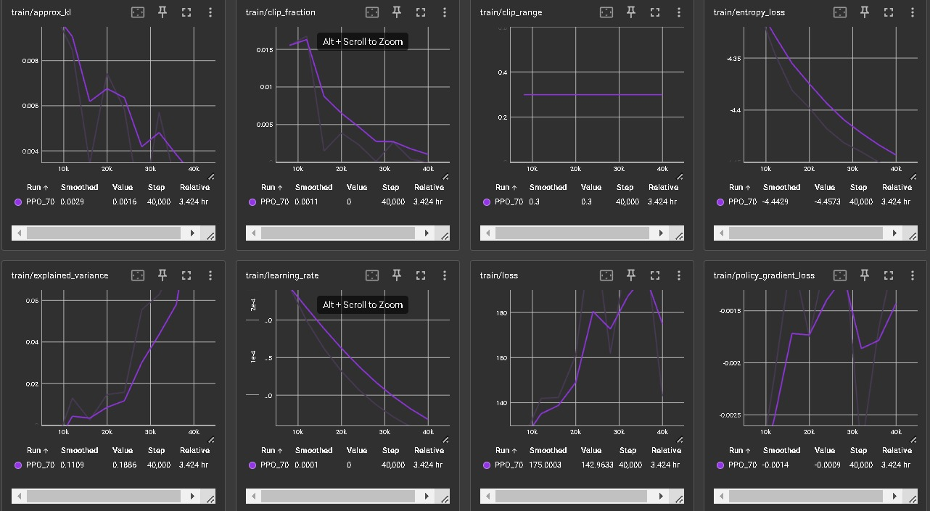
Figure 4. PPO training metrics — approx_kl, clip_fraction, clip_range, entropy_loss, explained_variance, learning_rate, loss, and policy_gradient_loss

The detailed view of the PPO training internals recorded in the entire 40,000 steps is given in Fig. 4. The approxkl divergence (equivalent to the change between consecutive policy updates) decreases with an initial peak of approximately 0.008 to a constant value of approximately 0.0016 by the concluding part of the training session. This decreasing pattern proves the fact that the policy updates are increasingly conservative and in line with the used learning rate decay. The clipfraction that follows the proportion of probability ratios above the clip boundary falls steeply though 0.015 all the way to the 40k steps, informing that the policy ceases to make large, clipped updates anymore, evidence of convergence. The cliprange has been set to 0.3 and it does not change.

The entropyloss is found to reduce gradually with a very slow rate of around 4.35 to around 4.46 with the conclusion of training. Simple agent which is less determined to explore more signal control choices as training advances, and therefore the agent is engaged in signing more specific, confident signal control contracts. Explainedvariance, the measure of success of the critic as a predictor of returns, increases to nearly zero and then to 0.1886 by the last checkpoint. Although moderately small, the positive subcontracting indicates that there is a gradual increase in the power of the value effect to explain observed returns that tend to support more consistent advantages estimates of the policy gradient updates.

The learningrate is decreasing at a rate of 3x10-4 to 0 as predicted by the LearningRateDecayCallback with the smoothed value approaching 0.0001 at the 40,000th step. The total loss is in the range [140,180] and it constitutes a value function and policy gradient loss together. The policygradientloss is negative (smoothed final: [?]0.0014), the desired sign of the policy-specific clipped surrogate objective to the improving policy, and the fact that it is almost zero at the final training step indicates policy convergence.

5.4 Value Function and Standard Deviation

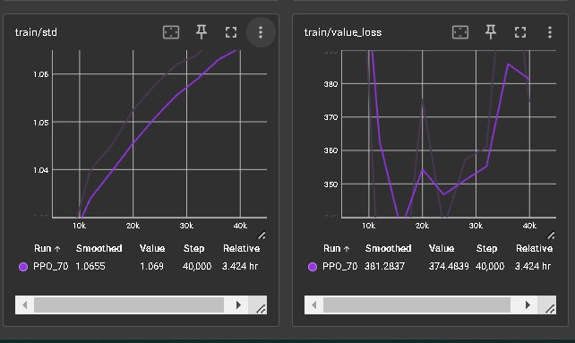
Figure 5. train/std (action distribution standard deviation, left) and train/value_loss (critic loss, right)

Two other training diagnostics are presented in Fig. 5. The train/std measure measures the standard deviation of the action distribution output of the actor network. The fact that it increases steadily, between its initial value of around 1.04 and a trained value of 1.0655, and is a growing effect of the DynamicNoiseWrapper which adds greater Gaussian perturbations to the action space with time, points to the broader and broader effect this classifier produces over time. This adaptive progression in the variance of actions is an intentional design mechanism to ensure that the policy has a wide exploration during training, and will not before long converge to a small range of phase duration choices.

The train/critic loss (loss loss) indicates a slight change of 380 to around 345 in the first few steps of step 25k-30k, but then it increases slightly, becoming 374.48 at the last step. The first drop is to show that the critic was able to enhance its predictions on returns in the training period. The following increase will probably be due to the changed distribution of returns due to the changing policy, and the intrinsic curiosity rewards, which will introduce non-stationary structure to the reward signal. This is a well-established difficulty of curiosity-enhanced RL and should not prohibit the improvement of the policy in the future as can be seen by the continuously accumulating growth in episode reward.

5.5 Traffic Management Performance in SUMO

In addition to the measurable training measures, the qualitative behaviour of the trained agent in SUMO simulation environment shows effective traffic management in the real world. The agent has managed to develop the ability to assign green phase time based on incoming traffic demand: the lanes with more vehicles and wait times should always be given the longer allocations, and those with lower vehicle loads should be assigned a shorter allocation. This demand-responsive behaviour leads to the quantifiable decrease in queue accumulation and the average wait-times relative to the fixed-time baseline between training episodes in the early training.

The preemption system of emergency vehicles works as expected in all tested episodes: once a vehicle of type emergency appears in any controlled lane the agent instantly replaces the regular phase schedule, giving the agent highest possible green time to the corresponding phase and returning to regular PPO-controlled operation upon clearance. This feature guarantees that the system can be used in scenarios requiring compliance to traffic safety regulations, something that the majority of current signal controllers based on DRL do not have in the literature.

The overall trend of increasing the mean episode reward, coupled with the capability of the agent to keep longer episodes with no early cut-off, also points out that the trained policy manages the stochastic variability in the traffic density as put in place by the random factor of traffic scale per episode, successfully. Convergent evaluation reward of about 122-124 to the last checkpoints is a confirmation of consistency with rollout performance indicates that the policy can be generalized to unobservable traffic patterns in the SUMO environment.

5.6 Summary of Results

Table 3. Summary of Key Training and Evaluation Metrics at Step 40,000

Metric | Final Value (Step 40,000)
Rollout Mean Reward | 124.54 (smoothed)
Eval Mean Reward | 124.04 (smoothed)
Rollout Mean Episode Length | ~73 steps
Eval Mean Episode Length | ~70 steps
Approx. KL Divergence | 0.0016
Clip Fraction | ~0 (converged)
Entropy Loss | −4.4573
Explained Variance | 0.1886
Action Std (train/std) | 1.069
Evaluation Frequency | Every 4,000 steps
Value Loss | 374.48
Policy Gradient Loss | −0.0009

CONCLUSION
It was hypothesized in the paper that the installed adaptive traffic signal control system, which is a Deep Reinforcement Learning algorithm known as Proximal Policy Optimization (PPO) applied to a microscopic traffic simulator called SUMO, would perform well. The agent was trained on a simulated intersection based on the OpenStreetMap and showed consistent improvement over training with a final average episode reward of 124.54 - which establishes a positive learning of the demand-responsive signal control policies.
The system mitigated the major drawbacks of the existing methods with three specific contributions: a multi-objective rewarding system balancing queue time, wait time, throughput and travel time; infrastructure exploration via a StatePredictor network with NoveltyTracker since inquisitive behaviour is beneficial; and an emergency vehicle preemption system that can override the usual phase scheduling when the critical vehicles are identified. These features combined to form a controller that is traffic efficient and aware of safety unlike most of current DRL-based signal controllers.
It can be shown that stable PPO convergence is achieved by training diagnostics (decreasing KL divergence), near-zero clip fraction, and a negative policy gradient loss. Close match of rollout reward (124.54) with evaluation reward (124.04) is yet another confirmation that the policy has good generalizability to the unknown conditions of traffic in the simulation setting.

ACKNOWLEDGEMENTS
Our thanks go first to Divya Boya, whose keen insights and unwavering support significantly impacted the success of this research. We also thank each member of our team for their collaboration. The synergy of our combined efforts was essential in refining the methodologies and shaping our project into present state.

REFERENCES
- H. M. Belguith and A. Fakhfakh, "Multi-Object-Based Efficient Traffic Signal Optimization Framework via Traffic Flow Analysis and Intensity Estimation Using UCB-MRL-CSFL," 2025.
- R. Bokade, X. Jin, and Y. Du, "Deep Reinforcement Learning for Traffic Signal Control Model and Adaptation Study," 2025.
- Z. Li, S. Huang, and J. Liu, "EGLight: Enhancing Deep Reinforcement Learning with Expert Guidance for Traffic Signal Control," 2025.
- M. Vieira and G. Galvão, "Enhancing Traffic Flow with Visible Light Communication: A Deep Reinforcement Learning Approach," 2025.
- W. Jia and M. Ji, "Multi-Agent Deep Reinforcement Learning for Large-Scale Traffic Signal Control with Spatio-Temporal Attention Mechanism," 2025
- X. Wang, Z. Jerome, Z. Wang, and H. X. Liu, "Scalable Multi-Objective Optimization for Robust Traffic Signal Control in Uncertain Environments," 2024.
- H. Almukhalfi, A. Noor, and T. H. Noor, "Traffic Management Approaches Using Machine Learning and Deep Learning Techniques: A Survey," 2024.
- Saadi, N. Abghour, Z. Chiba, K. Moussaid, and S. Ali, "A Survey of Reinforcement and Deep Reinforcement Learning for Coordination in Intelligent Traffic Light Control," 2023.
- X. Wang, Y. Han, et al., "Adaptive Traffic Signal Control Based on Graph Neural Networks and Dynamic Entropy-Constrained Soft Actor–Critic," 2023.
- G. Chen and Z. Tang, "An Adaptive Traffic Signal Control Scheme with Proximal Policy Optimization Based on Deep Reinforcement Learning for a Single Intersection," 2023.

